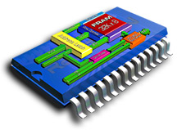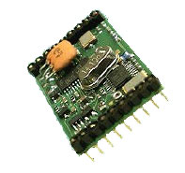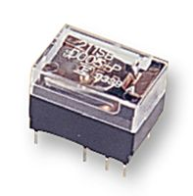
PIC18C452
Microprocessor

FM25C160 FRAM
X2010 Transceiver
AD8369 RF VGA
Bypass Relay
RS232 PC Terminal
50Ω Antenna

